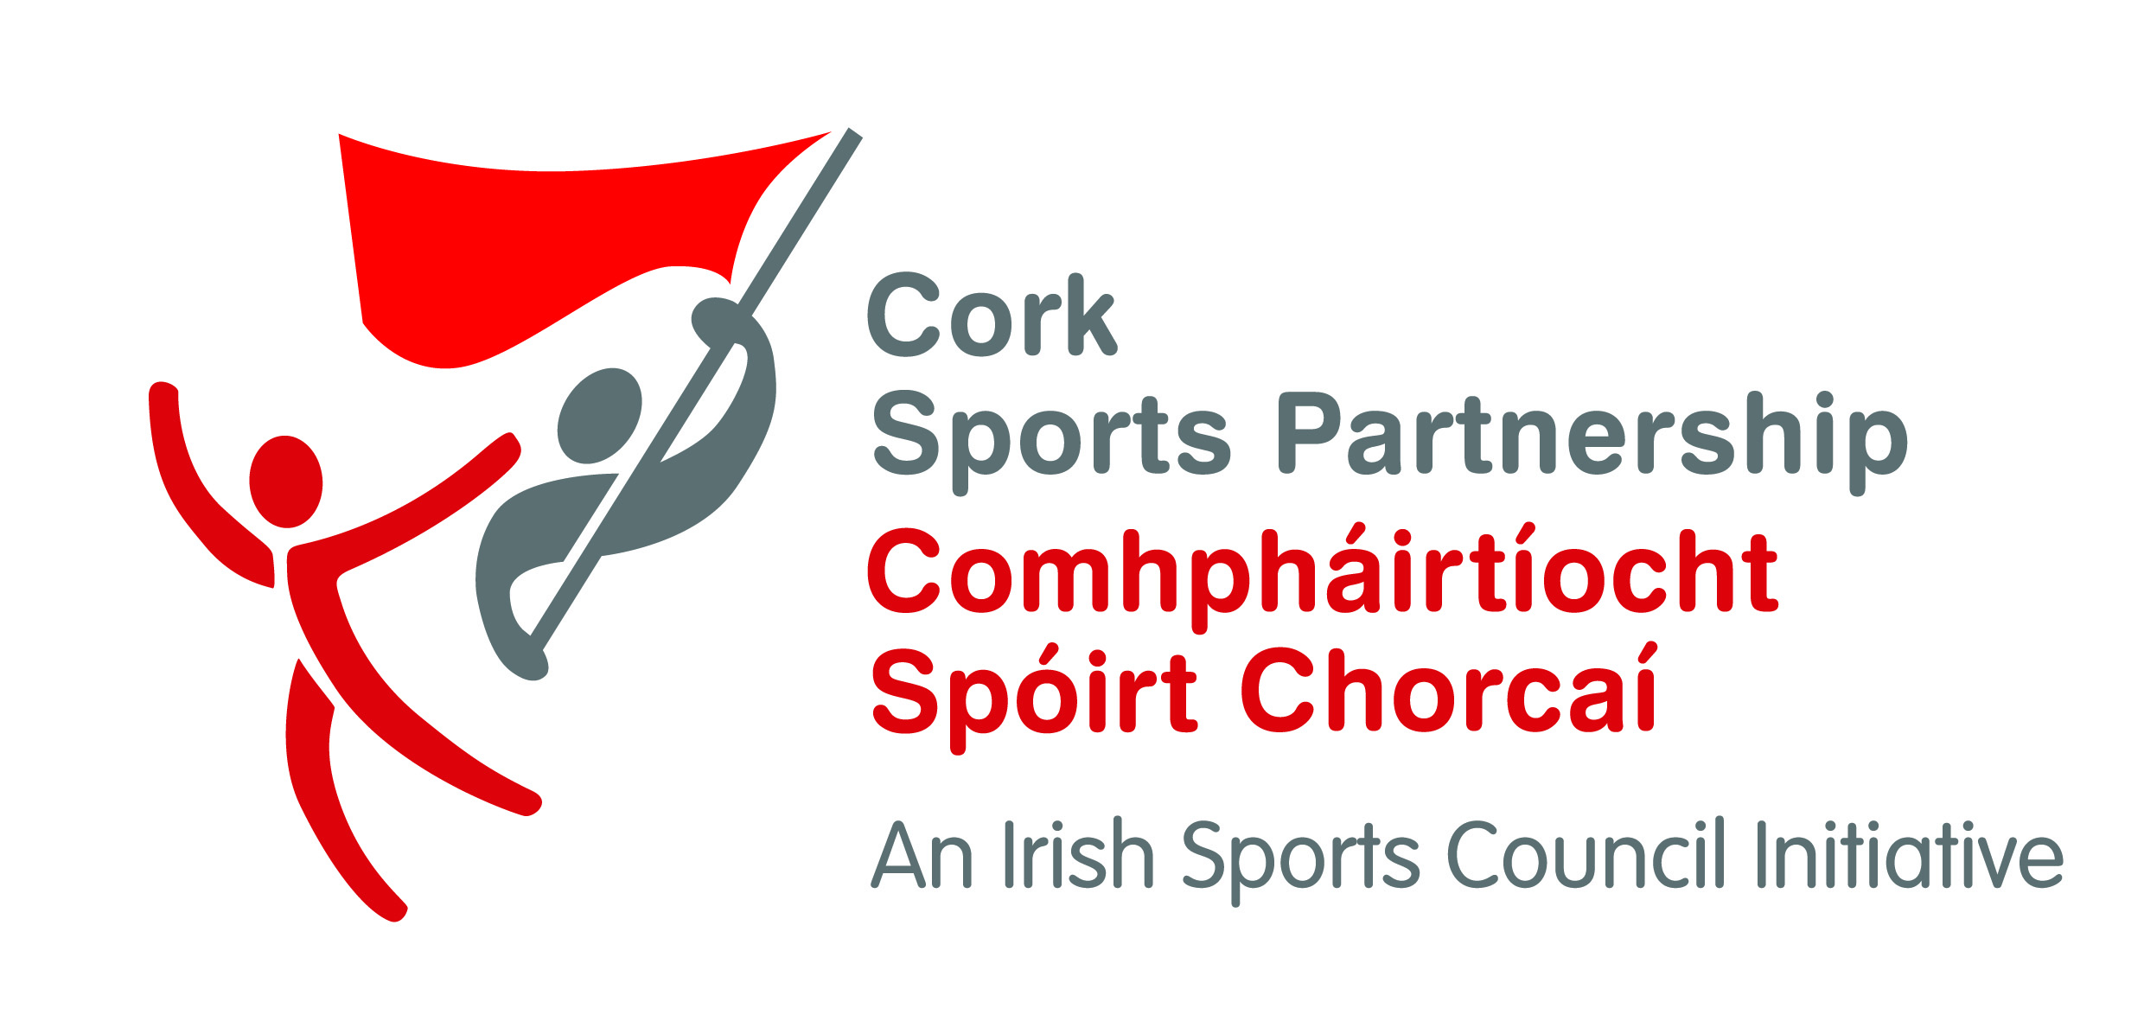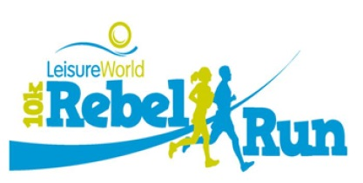

Dear Rebel Run Participant,

Thank you for registering for this year’s Leisureworld Rebel Run 10k and 5k events. The event is organised by Cork Sports Partnership and supported by Leisureworld, Cork Institute of Technology, Athletics Ireland and our event partners for 2015 John Buckley Sports.

A few pointers of interest to you before Sunday:

* Each participant **MUST SIGN IN** for the event during the following times **Fri 5-8pm** and **Sat 12-2pm and Sun 8am-9am**. Sign in will take place in the meeting room at the Track Stand in CIT (access from just behind the track). You can also sign in for a friend as long as you bring their E Ticket email/details. Here you will collect you Race Number, Timing Chip as well as your Goody Bag including your souvenir t-shirt.
* **There will be sign in on the morning between 8am and 9am.**
* **Parking** is available in both CIT and Leisureworld car parks.
* Please pin your event number to the front and mark clearly on the reverse your **Emergency Contact Number and any medical conditions** that we should be aware of.
* **NO Headphones** to be worn, roads are open with traffic, so for safety everyone must be able to hear traffic and marshal instructions at all times.
* The event starts at **9.45am sharp** from the back of the CIT athletics Stand (please note new start area from previous years)
* The race will finish on the Running Track @ CIT-light refreshments provided.
* Medical support is being provide by the Irish red Cross
* Water stop for the 10k will be approx. 5km mark
* There will be **KM** markers only on the route for both 5k and 10k events.
* There will be category prizes for 10k participants and sport prizes for all participants.
* Prize categories and further details are available under on [www.rebelrun.ie](http://www.rebelrun.ie)

We look forward to seeing you on Sunday.

The Rebel Run Team

