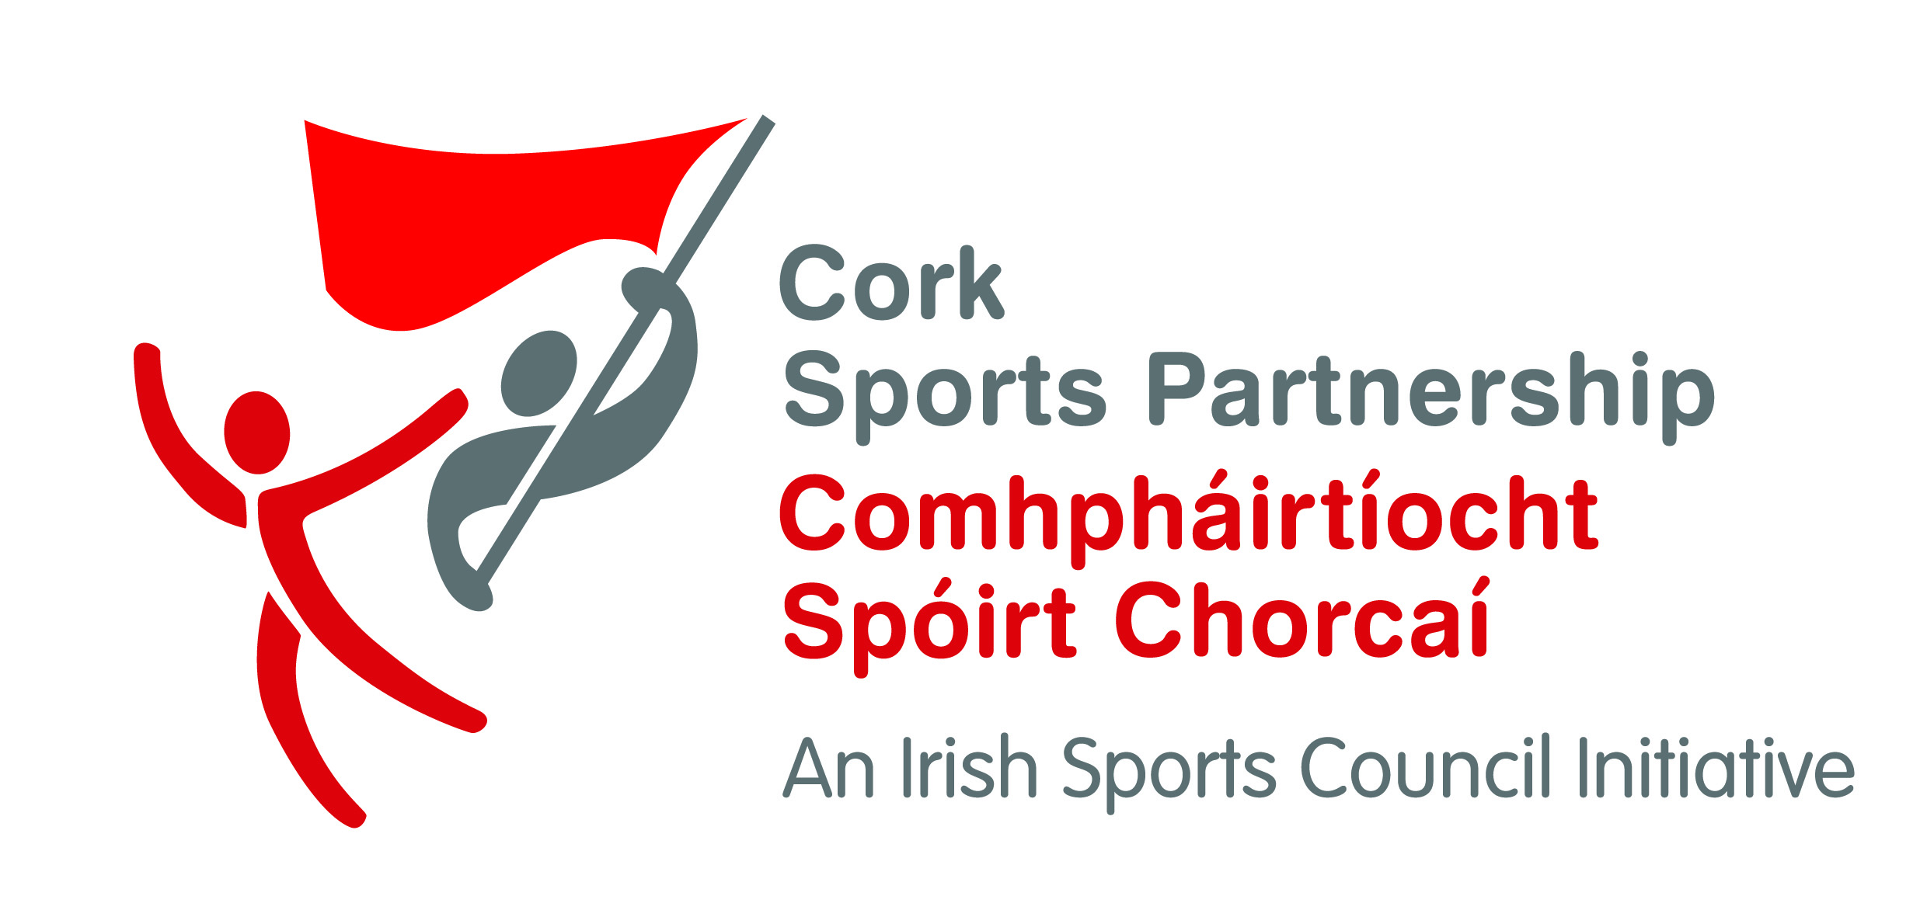
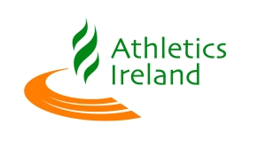
Cork Little Athletics Programme

Club Details:

Club Name & Address
Club contact & position in the Club:
Mobile Number of contact:
Email:
Club facilities:

Schools Details:
Approximate number of schools in catchment area:

School List:

Notes/Additional information:

Please return registration form to: Maurice O’ Sullivan, Cork Sports Partnership, Yeats House, Barrack Square, Ballincollig, Co Cork.

